Woolf Veterinary Forensics Consulting – Postmortem Examination
Date: ____________ Animal ID#: __________________ Agency:_____________________________
Case #_________________________ Examining Veterinarian:__________________________
Species: _______ Breed: ___________________________ Color: _____________________________
Weight: ________ Sex: _____ Age est.: _______ Markings: _________________________________
Date of Death (if known): __________ Euthanized? (Y/N) Method: ________________________
Photographer: _________________ Others Present: _____________________________________
Start time: _________ End time: _________ Microchip # _________________________________
Subcutaneous Fat | Adequate  Inadequate  Serous Atrophy  Absent | Omental Fat | Adequate  Inadequate  Serous Atrophy  Absent | Mesenteric Fat | Adequate  Inadequate  Serous Atrophy  Absent |  | Perirenal Fat | Adequate  Inadequate  Serous Atrophy  Absent | Cardiac Fat | Adequate  Inadequate  Serous Atrophy  Absent
Body Condition Score | /9 |  |  |  |  | State of decomposition
Skin | Normal Abnormal
Ears | Normal Abnormal
Eyes | Normal Abnormal
Musculoskeletal system | Normal Abnormal |  |  |  |  | Bone Marrow
Oral cavity/teeth | Normal Abnormal
Reproductive system | Normal Abnormal
Heart and circulatory | Normal Abnormal
Lungs and respiratory | Normal Abnormal
Diaphragm | Normal Abnormal
Liver and Gallbladder | Normal Abnormal
Stomach | Normal Abnormal
Intestinal tract | Normal Abnormal
Pancreas | Normal Abnormal
Spleen | Normal Abnormal
Kidneys | Normal Abnormal
Bladder | Normal Abnormal
Lymph nodes | Normal Abnormal
Adrenal glands | Normal  Abnormal
Brain | Normal  Abnormal
Animal ID# __________________ Case #____________________________ Page 2 of _______
Postmortem Examination (pg. 2)

Samples retained for testing: ______________________________________________________________________________________________________________________________________________________________________________________________________
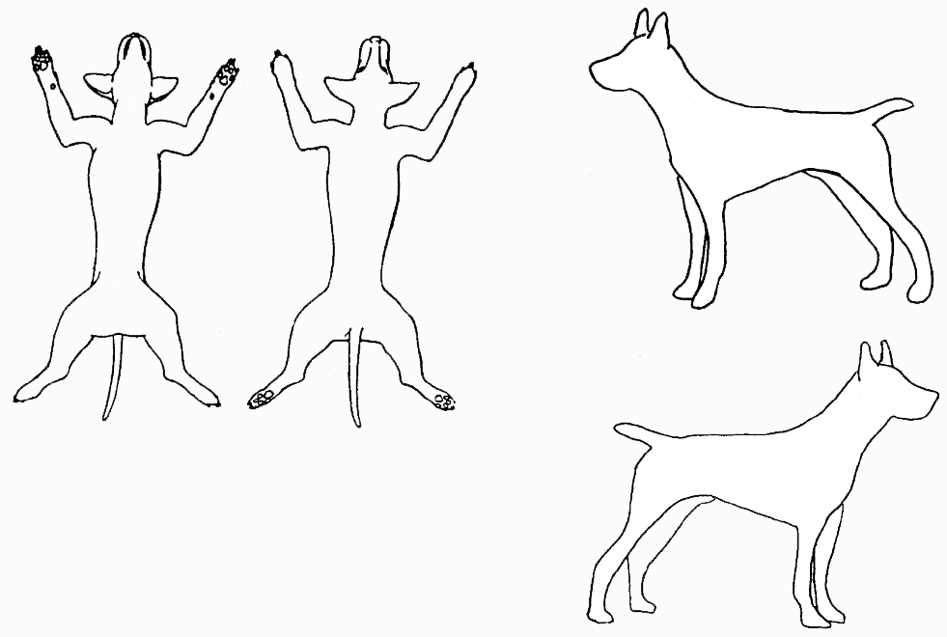
Wounds and Scars Diagram
Fresh wounds:
Old scars:
Other where applicable:

